**Genomic surveillance of SARS-CoV-2 in Belgium**

Report of the National Reference Laboratory (UZ Leuven & KU Leuven)

**Situation update – 23th of February 2021**

**(report 2021_13)**

**Executive summary**

Genomic surveillance in Belgium is organised around 3 different arms aiming to monitor the emergence and the further spread of specific viral populations (variants of concern, VOCs) which may impact disease control and/or vaccination strategies.

Through baseline surveillance, an unbiased selection of positive samples from 24 sentinel labs (selected based on geographical dispersion and diversity of clinical patterns) are analysed in designated sequencing platforms. Currently, 6.338 Belgian sequences are available on GISAID. During weeks 6,7 and 8, 670 samples have been sequenced as part of the baseline surveillance, among which 292 were 20I/501Y.V1 (43,6%), 34 were 20H/501Y.V2 (5%) and 8 were 20J/501Y.V3 (1,2%).

The majority of new infections occurring in Belgium are now caused by a VOC. Collectively, they are now driving the dynamics of the epidemic and are causing the number of daily infections to start rising again.

Authors (National Reference Laboratory – UZ Leuven and KU Leuven):

*Piet Maes, Lize Cuypers, Guy Baele, Els Keyaerts, Elke Wollants, Marc Van Ranst, Emmanuel André*

Collaborators of this report (KU Leuven): *Tom Wenseleers*

With the collaboration of the laboratories of UCL, ULB, UMons, UNamur, ULiège, Ugent, UAntwerpen, Jessa ZH, AZ Delta, AZ Klina, IPG, AZ St Lucas Gent, OLV Aalst and UZ Leuven/KU Leuven.

**Table of content**

1. International context
2. Baseline surveillance and proportion of VOCs among new infections in Belgium
3. Temporary (and urgent) utility for a complementary reflex VOC PCR
4. Positivity rate in federal platform laboratories
5. **International context**

Since the end of the year, 4 variants of concern (VOCs) have arisen independently of one another in the United Kingdom (20I/501Y.V1), South Africa (20H/501Y.V2) and Brazil (20J/501Y.V3 and P.2). These variants harbour several mutations and deletions associated with higher infectiousness and immune escape. All variants are spreading internationally, with 3 VOCs having been detected to date in Belgium (1.875 for 20I/501Y.V1, 255 for 20H/501Y.V2 and 19 for 20J/501Y.V3).

1. **Baseline surveillance and proportion of VOCs among new infections in Belgium**

Since support was offered by the federal government end of December 2020, both the temporal coverage (number of sequences performed per week) and geographical coverage (number of collection sites) have improved. Currently, 6.338 Belgian sequences are available on GISAID.

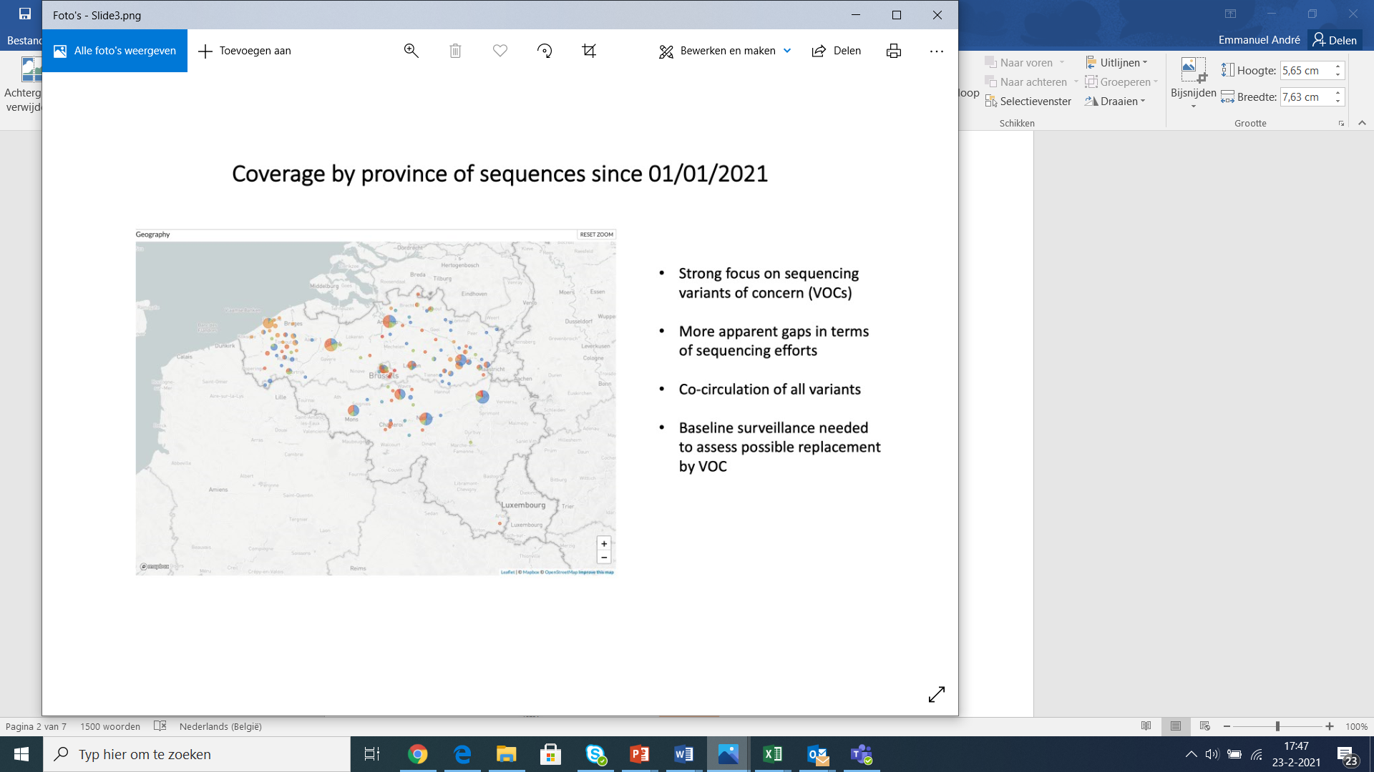

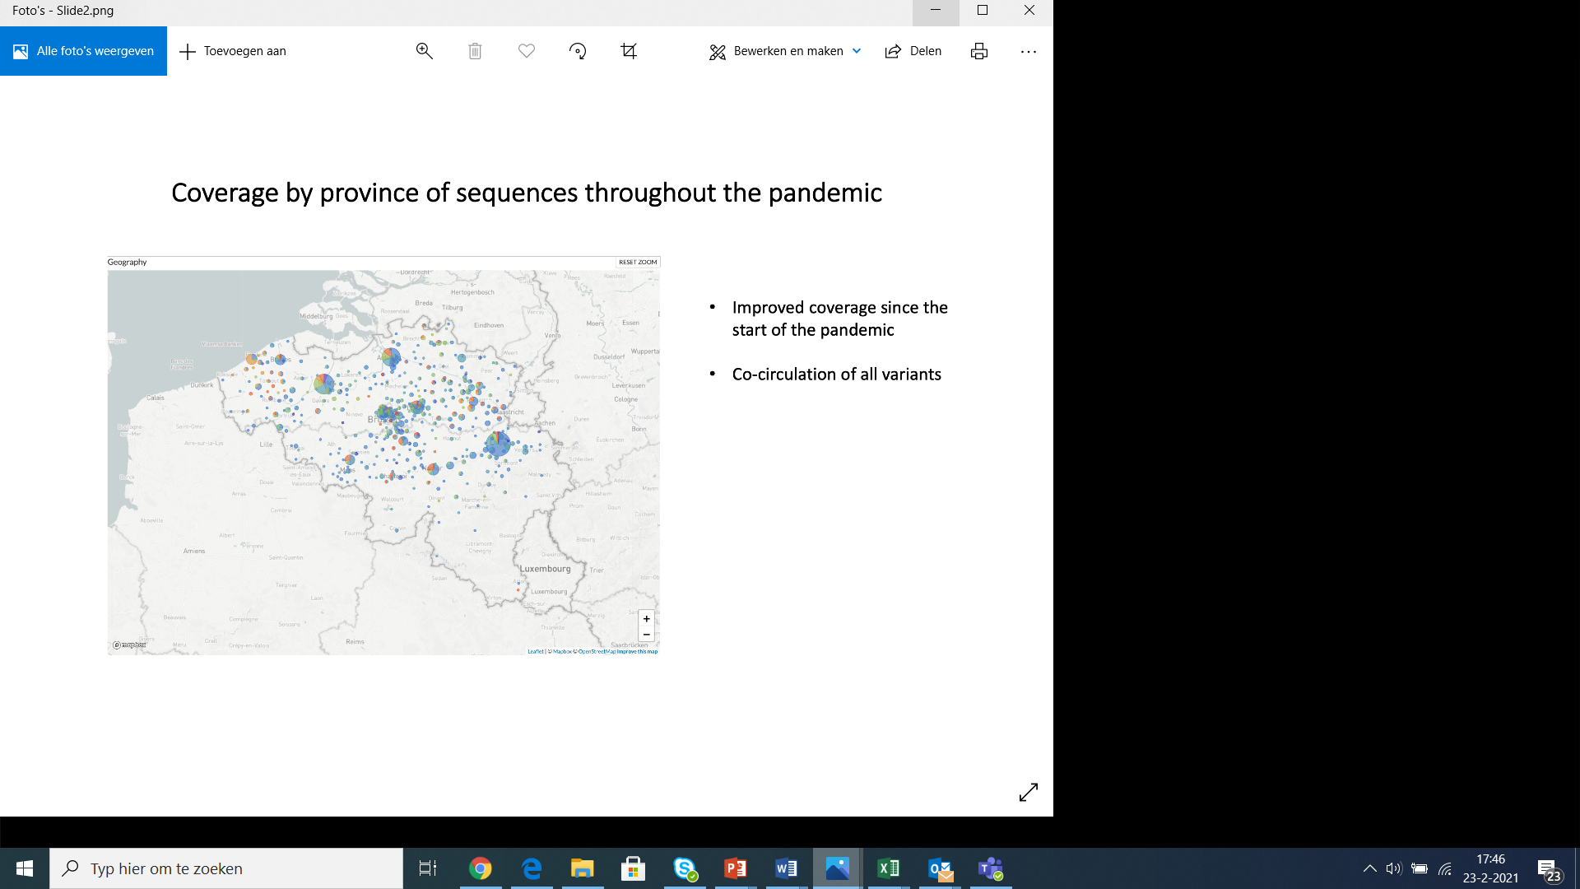

**Figure 1:** Geographical coverage of the genomic surveillance network in Belgium since February 2020 (left) and 1st of January 2021 (right).

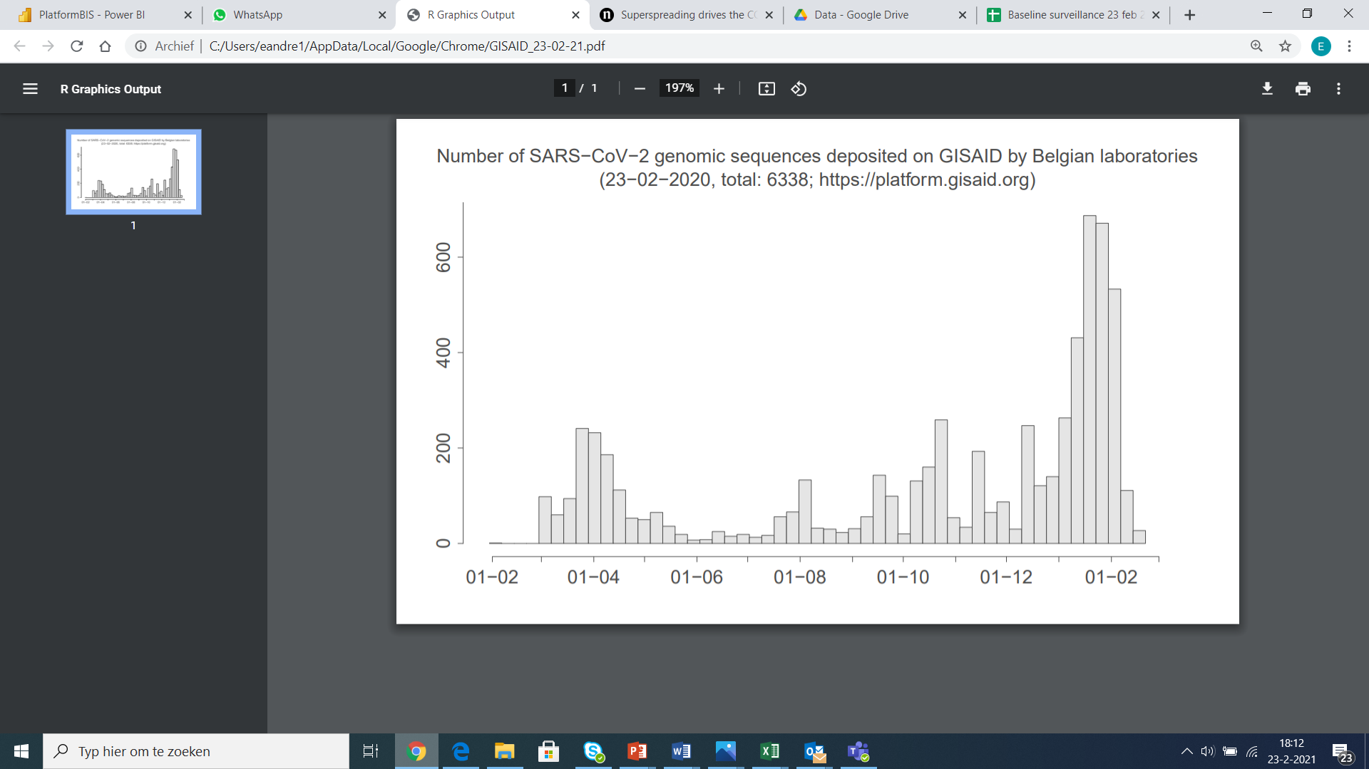

**Figure 2:** Number of sequences deposited on GISAID per week of sampling since the start of the outbreak in Belgium.

Follow-up of 501Y.V1 (B.1.1.7) is performed using an additional indicator, which is the “S dropout” signal detected among positive COVID-19 PCRs reported by the 8 federal platform laboratories. In order to get the best view on the number of recent infections actively contributing to transmission, we consider for the daily follow-up only positive samples for which the N gene has a Cq value under 25. By excluding for this analysis the samples with a Cq value between 25 and 30, we avoid to include possibly older infection and possible false positive S dropout signals that can occur when the signal is close to the limit of detection.

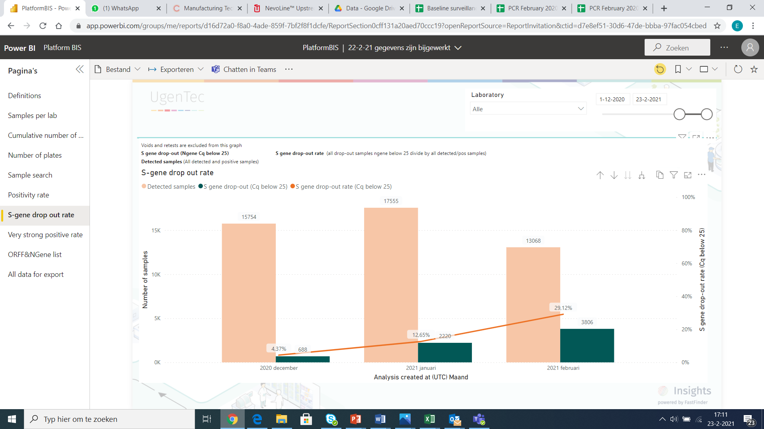

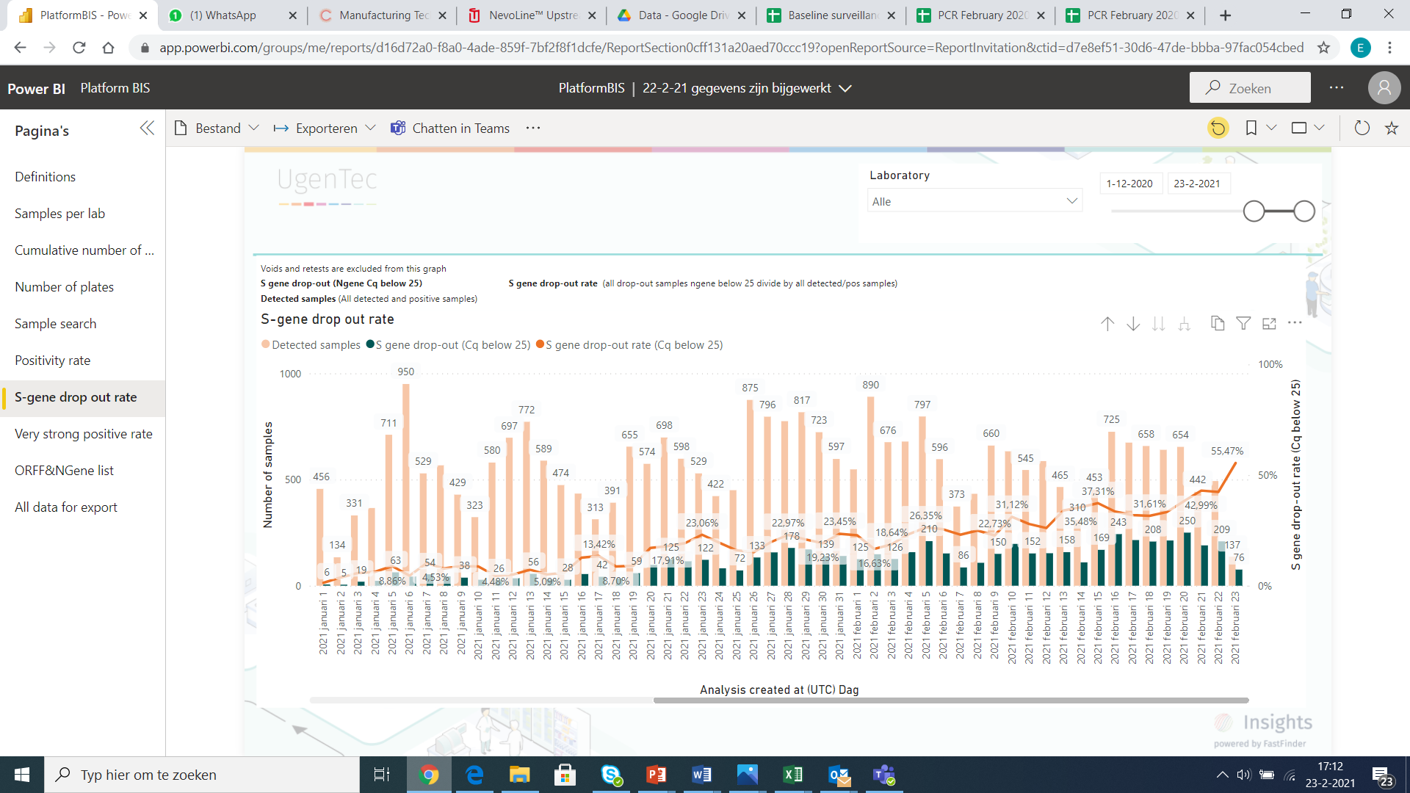

**Figure 3:** Monthly (figure above) and daily (figure below) evolution of the proportion of infectious samples detected among all positive tests diagnosed in the federal platform laboratories (Presence of the S dropout signal and Cq <25). Based on these figures, we estimate that over 40% of the people infected one week ago were infected with a 501Y.V1 variant. This phenomenon is observed in all regions of the country.

An accurate estimate of the actual proportion of currently diagnosed samples that are 501Y.V1 can be obtained using a binomial GLMM fitted to the S dropout data (Figure 4). This analysis shows that 70% [67-72%] 95% CLs of all currently diagnosed infections and 80% [78-83%] of all new infections (at time of infection, counted 1 week before diagnosis) are now (on the 23d of February) estimated to be 501Y.V1. This is only slightly lower than the ca. 90% that was estimated in our report of the 28th of January, which used the data from the 1st to the 22nd of January. The growth advantage of 501Y.V1 compared to all other strains is estimated to be 8.8% [8.4-9.3%] per day, which assuming a generation time of 4.7 days, would translate to a transmissibility advantage of 51% [48-55%]. Several factors may explain the slight reduction in the estimated growth advantage, including various sampling biases (e.g. a shift from active surveillance to more random baseline surveillance) as well as the invasion of other variants with a growth advantage, such as 501Y.V2 & 501Y.V3

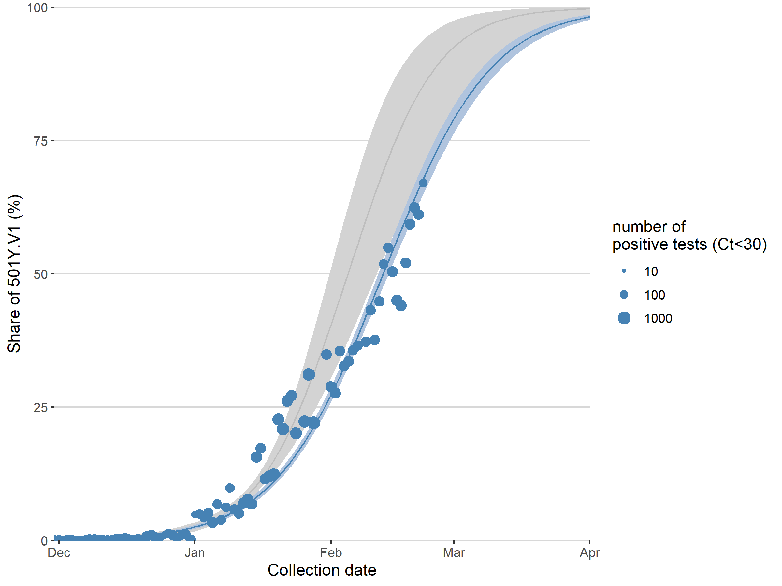

**Figure 4:** Estimated increase in the relative abundance of the 501Y.V1 variant in Belgium based on S dropout data (mean and 95% confidence intervals, binomial GLMM with random intercept for laboratory and an observation-level random effect to take into account overdispersion, with correction for the expected proportion of true positives, estimated from an independent binomial GLMM fitted to sequencing data of S dropout samples; currently 99.9% of all S dropout samples are indeed 501Y.V1). An extrapolation up to the first of Aprils is shown. Shown in grey is the fit we made in our report of the 28th of January, using the data from the 1st of January until the 22nd of January only. In this analysis, only tests with Ct values for the N and ORF1ab genes < 30 were included.   
Code available at

<https://github.com/tomwenseleers/newcovid_belgium/blob/main/analysis_update_20210223.R>

We can further observe that the increase in the share of 501Y.V1 among newly diagnosed infections occurs at approximately the same rate in different regions in Belgium (Figure 5), although initial introduction of 501Y.V1 is inferred to have occurred significantly earlier than average in Brussels, Antwerp and Louvain-la-Neuve and significantly later than average in Namur, Leuven and Mons.

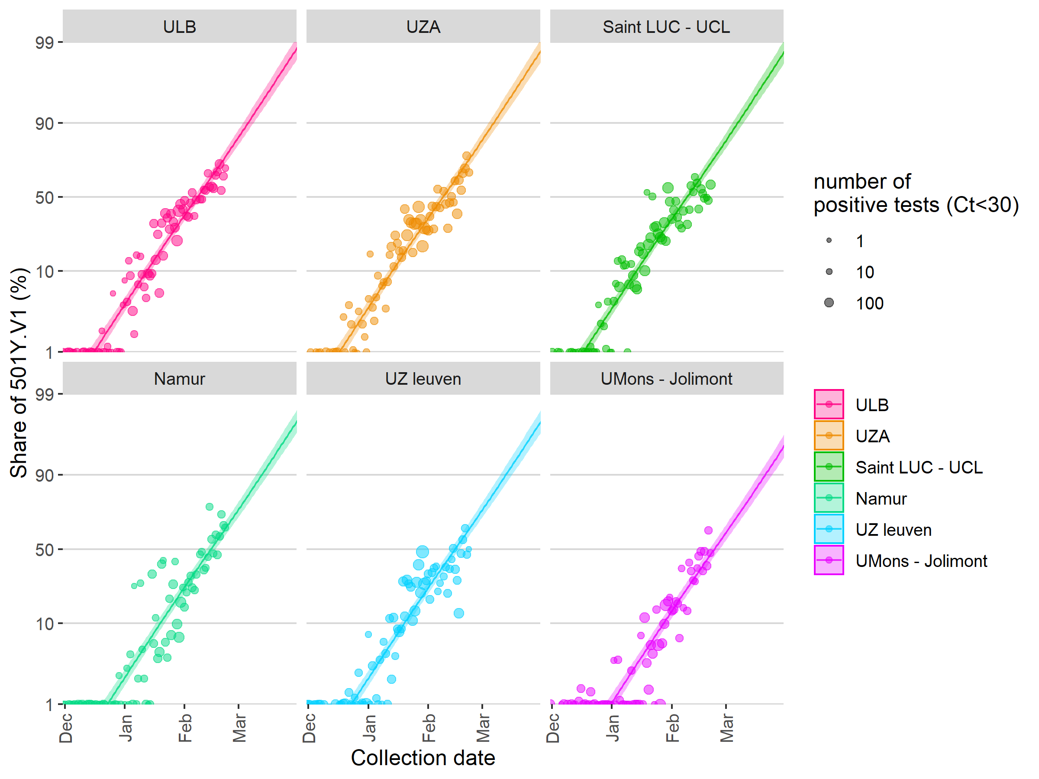

**Figure 5:** Average share of 501Y.V1 among newly diagnosed infections inferred from a binomial GLMM (cf. Figure 4), plotted separately for different regions in Belgium (predicted means and 95% confidence intervals).

Due to these observed increases in the share of the 501Y.V1 variant among newly diagnosed infections, and its increased transmissibility of ca. 50%, variant 501Y.V1 has now become a main determinant in driving up the effective reproduction number (Re) of the SARS-CoV2 virus in Belgium. Using the fitted proportion of the 501Y.V1 variant among new infections, combined with the estimated transmission advantage of 51% and overall Re values estimated from the Sciensano case and testing data, we can readily estimate the Re values of the 501Y.V1 strain and the other circulating variants separately (Figure 6). This follows from the fact that the overall Re value is at any time an average of the Re values of the individual variants, weighted by their frequency. In Figure 6 we calculated the Re values from the Sciensano case data based on the intrinsic growth rate in number of cases, calculated using a gamma distributed generation time of 4.7 days with a SD of 2.9 days, and with the growth rate calculated as the first derivative of a binomial generalized additive model fit (taking into account weekday, a 32 df cubic spline in function of time of diagnosis, and a 5 df cubic spline in function of number of tests performed). In contrast to the Re analyses that are routinely reported, this analysis corrects for variable testing intensity. It can be observed that this analysis estimates the overall Re value (at time of diagnosis) to already be well above 1, at 1.20 [1.18-1.22]. In addition, while the Re value of the other variants is estimated to be much below 1 (0.85 [0.84-0.87]), the Re of the 501Y.V1 strain is estimated to lie at 1.30 [1.27-1.32]. We expect that the overall Re value would still rise a little further, almost approaching that of the 501Y.V1 strain as 501Y.V1 would further displace the other variants.

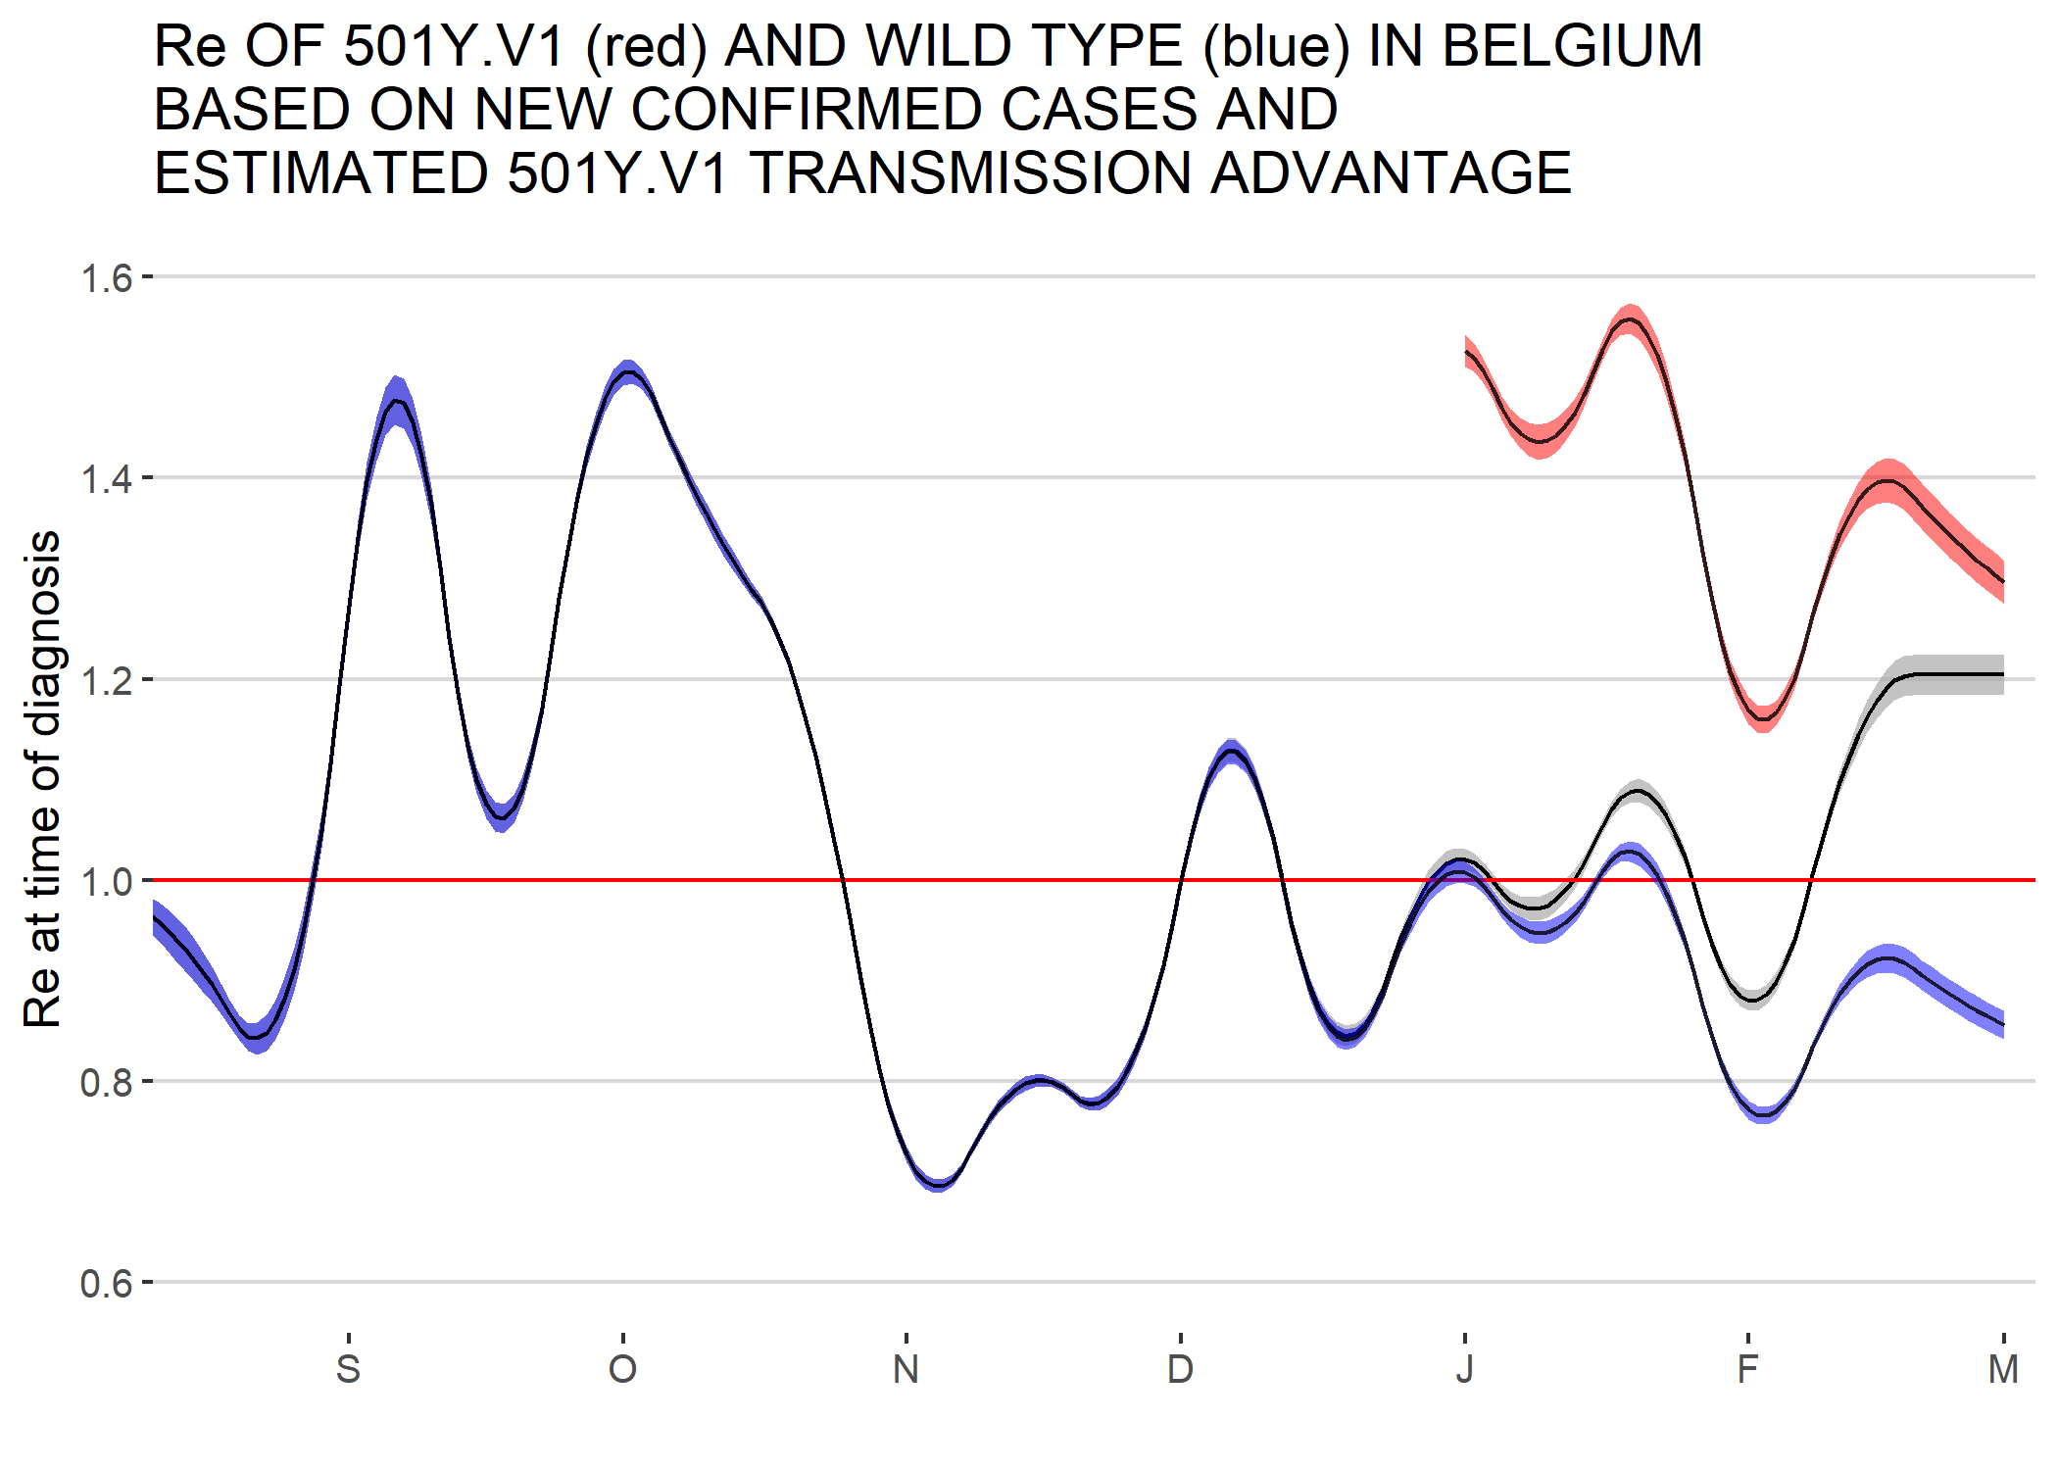

**Figure 6:** The evolution of the basic reproduction number Re in Belgium (black line) is now heavily influenced by the spread of the highly contagious 501Y.V1 strain (red line), which emerged in Belgium in the middle of December 2020, and which at any time is estimated to have an Re value that is 1.51 times higher than that of the other circulating variants (blue line) (shaded areas = 95% confidence intervals). Overall, the average Re values, as well as the Re values of the 501Y.V1 strain and the other circulating strains, are heavily influenced by changes in behaviour, the implementation of non-pharmaceutical interventions, and so these tend to fluctuate quite a bit. Re values beyond the 19th of February have been extrapolated, and the flat trend shown may not be reliable.

Aside from the 501Y.V1 variant, baseline sequencing also inferred the presence of two other variants of concern, 501Y.V2 and 501Y.V2. During weeks 6,7 and 8, 670 samples have been sequenced as part of the baseline surveillance, and of these 292 were 20I/501Y.V1 (43,6%), 34 were 20H/501Y.V2 (5%) and 8 were 20J/501Y.V3 (1,2%) (Figure 7). If we would fit a multinomial model to these data, we can estimate that among new lab diagnoses today 62% [57-66%], 6% [4-8%] and 2% [0-4%] would be by 501Y.V1, 501Y.V2 and 501Y.V3, and 70% [63-76%], 6% [3-9%] and 3% [0-8%] of all new infections (one week before diagnosis) (Figure 8).



**Figure 7:** Nextstrain build of currently available sequences from Belgium. VOCs are highlighted in dark orange (20I/501Y.V1), light orange (20H/501Y.V2) and red (20J/501Y.V3).

**8** based on a multinomial fit to the baseline sequencing data

1. **Temporary (and urgent) utility of a reflex VOC PCR**

Since the start of the COVID-19 pandemic, viral mutants have continuously emerged as a consequence of high level SARS-CoV-2 circulation. In a first phase, non-pharmaceutical interventions such as contact-restriction policies, have led to the selection of more transmissible variants. In a second phase, the virus is put under pressure to be able to evolve in populations with a partial herd immunity, and experiencing a stepwise rollout of vaccination.

During the upcoming months, a period characterized by incomplete immune protection, partial immunity status will probably become a major driver of selection for variants better adapted to escape human immunity. To date, a limited number of VOCs have been described, and controlling the spread of mutants harbouring an immune escape mechanisms (in particular S:E484K) at least during the vaccination rollout period.

Performing a reflex PCR on all (or a significant proportion) of positive samples would allow to rapidly detect and subsequently contain community clusters of transmission related to such VOCs. Considering the financial benefits made by clinical laboratories for diagnostic PCR tests, we consider that this reflex PCR should be performed at no cost for the public health budget. The implementation of such PCR should be considered as necessary as long as VOCs harbouring the S:E484K mutation remain a minority of the circulating strains and as long as the health inspectors can handle the workload related to the specific interventions required.

Based on a literature review, we list hereunder a series of combinations of mutations of concern that would allow to detect and characterize the currently described VOCs, namely 20I/501Y.V1 (B.1.17), 20H/501Y.V2 (B1.351), 20J/501Y.P1 (B.1.1.28.1) and 20J/501Y.P2 (B.1.1.28.2). The list of selected candidates is represented in the table below, and comprises mostly mutations located in the receptor binding domain of the Spike gene. The minimal requirement for such PCR would be to detect at least S:E484K and S:N501Y.

|  |  |  |  |  |  |  |  |
| --- | --- | --- | --- | --- | --- | --- | --- |
|  | S:N501Y | S:del69 | S:A570D | S:E484K | S:K417N | S:K417T | Orf1b del |
| 20I/501Y.V1 | YES | YES | YES | Possible | NO | NO | NO |
| 20H/501Y.V2 | YES | NO | NO | YES | YES | NO | YES |
| 20J/501Y.P1 | YES | NO | NO | YES | NO | YES | YES |
| 20J/501Y.P2 | YES | NO | NO | YES | NO | NO | YES |

1. **Positivity rate in federal platform laboratories**

The positivity rate among samples tested is expected to rise of there is insufficient testing capacity compared to the actual current need. We can observe that the positivity rate has increased from January to February, although it still remains under 10%.

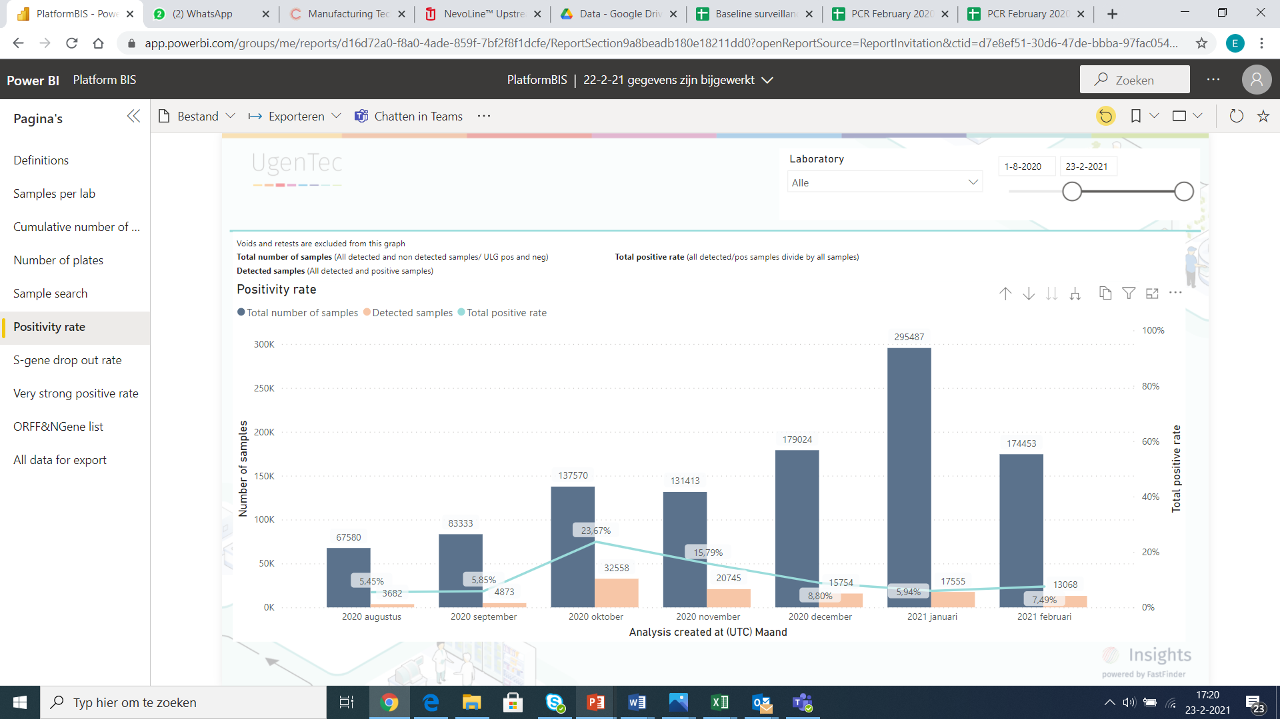

The proportion of positive samples presenting a very high viral load (Cq < 15) can be seen as the number of patients diagnosed during the first days of infection. This proportion tends to increase when the tracing is efficient in identifying transmission events, but can also be observed in the early weeks of a resurgence. This rate has increased from January to February, and is for the month of February at the level observed in September 2020, a few weeks before the second wave. This proportion has reached 30% during the last week, a proportion comparable with the month of October 2020, at the start of the second wave.

